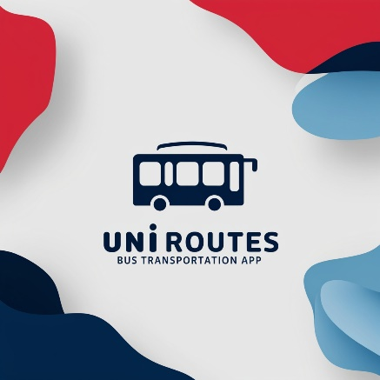


UNIROUTES
University Transportation Management system

Description:
Our Project Aims to address the challenges that face the universities transportation system coordinating and managing services within the universities environment also enhancing the overall journey.
UNIRoutes is an innovative transportation management solution designed to improve the efficiency of university transportation services. The platform simplifies bus scheduling. Provides real-time route tracking and helps students and staff easily manage transportation requests. By optimizing day-to-day operations, UNIRoutes ensures comfortable and reliable travel across campus, reducing delays and improving the overall user experience. Additionally, the system provides administrators with comprehensive tools to monitor Efficiency, adjust routes, improve service and improve transportation processes with comprehensive tools
Without a simple easy to use interface and a centralized system these processes can lead to communication gaps, inefficient time management which could lead to delays and unforeseen consequences resulting in a poor experience for students, faculty and staff.
Name | ID
Abdallah Basem Project Manager | 22100848
Ahmed Islam | 22101008
Belal Fathy | 22101311
Mazen Ahmed | 22100369
Eyad Elnakib | 22100757
Mahmoud Eid | 22100680
Customer Requirements

1-Bus Company Management:
The system should enable admins to add, update or delete bus companies.
2- Bus Management:
The system should enable admins and the bus companies to add, update or delete buses.
3-Route and Station Management:
The system should allow admins to add, update or delete bus routes and bus stations
4-Notifications:
The system should enable admins to send global or private notifications to all users, bus companies and drivers ensuring timely communication.
The system should also Send out Automated notifications.
5- Real-Time Tracking:
The system should enable admins to track the real-time location of all buses, should enable the company to track the real-time location of their assigned buses and must allow students to track the real-time location of their assigned bus.
6- Emergency Alerts:
Users should be able to send out emergency alerts directly through the system, enabling admins to verify and respond to these incidents swiftly.
7- About:
The system should display its users with the exact location of the pickup and drop-off points it should display relevant details such as pictures of the supervisor and driver, the bus, its number plate and contact information for both the supervisor and the driver.
8-Feedback System:
The system should allow users to submit feedback about their experience using the transportation service. This includes rating the service.
9- Staff Management:
The system should allow admins to add or remove drivers and supervisors for each bus route automatically adding them to the relevant group chat.
10- Reporting System:
The system should enable admins bus companies supervisors and engineers to report issues.
11- Maintenance Scheduling:
The system should allow admins, bus companies and engineers to schedule buses for maintenance.
12- Emergency Response:
The system must provide the admin and bus company with real-time data of all available buses. admin is able to immediately dispatch any of the available buses in the event of an emergency.
13-Manage booking:
The system must allow users to see how many seats are available on a bus before booking. The system must allow user to Book trip by daily subscription or semester subscription, modify their booking and cancel booking. Users should quickly rebook their frequent routes with one click
14-Finance Management:
The system should allow the banking system and the financial department to process payments, manage transactions, generate financial reports and detect potential fraud.
15-Data Management :
The system must allow users to view their trip history. admins are able to track and manage the overall trip history and all data and reports effectively.
16-Weather-Related Alerts:
The system must provide users with timely notifications regarding current weather conditions that may affect their trips and also integrate with ai to help admin avoid weather delays.
17-Rating System:
he system must allow users to rate drivers, supervisors, and their overall experience after each trip, ensuring user feedback is collected for continuous improvement.
18- Lost and Found:
The system allows users to report personal items left on the bus. Users can describe lost items. Enter the bus number or route. and provide contact details The system administrator or bus driver can update the system if the entry is found. and the user will be notified
19-Offline Mode:
The system will have an offline mode. It allows users to access essential information such as route maps, schedules and ticket details. Even if there is no internet connection. This ensures that users can still plan their trip or check their reservations when they don't have access to the web.
20- Google Maps Integration:
The system should integrate with Google Maps to provide users with accurate navigation, real time traffic and estimated time of arrival.
21- Features for Users with Disabilities:
The system allows people with disabilities to use voice commands and listen to information through text and speech. This makes it easier for people who are visually impaired or disabled to navigate the system.
22-User Requests and Voting System:
The system should allow users to submit transportation-related suggestions which can be voted on by other users and then reviewed and approved by admins.
23-Heatmap of Route Demand:
The system should provide heatmaps that display areas with high transportation demand enabling admins to adjust routes and schedules for better service.
24-Manage authentication:
The system will enable users to create accounts using their university email. It will support a login process that includes both password entry and two factor authentication (optional).
25-Manage roles:
The system will provide role-based access control for different users. Administrators will have the authority to assign roles such as student, driver, or system administrator, each with varying levels of access. Role management ensures that only authorized users can access and modify sensitive parts of the system

26-Schedule Viewing:
Schedule Viewing: Users can view the daily, weekly, and semester bus schedules, which will show the routes, timings, and bus numbers in an organized format, making it easy for them to find the right bus.
27-Favorites:
The system offers a (Favorites) feature allowing users to mark specific bus routes or stops as favorites. These are saved in your profile for quick and easy access. Reduce the need to search.
28-QR Code Generator:
A unique QR code or barcode is automatically generated for each bus ticket. This code will act as a digital ticket. Makes it easy to scan when boarding.
29-AI Integration: The system will include AI-powered features to improve user experience...
- Driver Behavior Monitoring: AI monitors and analyzes driver behavior by providing feedback on driving style.
- AI Feedback Classification: AI classifies and analyzes user feedback. Helps administrators identify and resolve issues more efficiently.
- Chatbot: AI-powered chatbot helps users with common questions like finding best routs. Viewing the schedule and troubleshooting of the system.
- Predicted route disruptions and maintenance needs: AI analyzes historical data and other factors to predict potential route disruptions such as traffic and identify maintenance needs. for buses
- Speed ​​and Altitude Monitoring: AI monitors the speed and height of the bus (if applicable) for safety and regulatory compliance.
- Integrated with Google Maps: Google Maps is used for real-time route updates and visual navigation. Makes it easier for users to plan their trips...
- Route Guidance: AI provides users with personalized route recommendations based on previous settings and current conditions. to optimize their travel experience
30-Help Center:
The system has a help center where users can get support for various issues. This will include questions asked. The same goes for contact options like live chat, email, or AI chatbots.
31- Wallet Management:
The system must allow the user to add wallet and recharge wallet if exist.

SUBSYSTEMS
 | Subsystem | Subsystem Functions | Subsystem Interface
A | GPS system | -Tracks Real Time location of university buses  -Provides live maps showing buses, stations and estimate travel time | Interface GPS {  -public void track_location(int bus_id)  -public Map Live_Map()  -public void Estimate_Travel(int bus_id, int Station_id)}
B | Weather system | -Retrieves and displays current forecast conditions  -Provides Weather impact analysis on operations  -Sends alerts for severe weather | Interface Weather{  -public String Forecast()  -public Boolean Weather_Warning()  -public void Display_Weather_Impact()}
C | Rating system | -Collects Feedback from passengers  -Evaluates integrity of ratings | Interface Raiting{  -public boolean collect_feedback(int route_id, int passenger_id, double rating)  -public boolean evaluate_raiting(int rating_id)}
D | Maintenance system | -Tracks maintenance management with engineers  -Logs Maintenance to ensure bus safety | Interface Maintenance{  -public Boolean track_maintenance(int bus_id)  -public condition Bus_condition(int bus_id)}
E | Financial system | -Manages Budget for Transportation department  -Tracks Revenue  -Handles customer purchases | Interface Finances{  -public double budget()  -public double Revenue()  -public boolean purchase(int passenger_id)}
F | Authentication system | -Provides secure login for students and staff  -Allows authenticated users to access certain features of the app according to their level | Interface Authentication{  -public boolean secure_login(int user_id)  -public boolean Authorized(int user_id)  -public boolean Authorization_level(int user_id)}
G | Scheduling system | -Organizes transportation scheduling for buses  -Allocates Buses according to multiple factors  -Sends alerts to passengers for schedule changes | Interface Schedule {  -public boolean Organize_shedule(int route_id,DateTime time)}
H | Notification system | -Sends notifications to students and staff  -Provides real-time updates via emails or in app notifications | Interface Notifications{  -public boolean Send_Notification(String Massage)  -public boolean RealTime_Updates(String Massage)}
I | History-Data system | -Stores and retrieves data and trip history  -provides better analysis and visualization | Interface Data{  -public boolean Store_data(int trip_id)  -public Data Retrieve_DATA(int trip_id)  -public Analysis Perform_Analysis(Data data)}
J | Booking system | -Allows the user to book his transportation plans  -Allows the user to book a specific seat | Interface Booking{  -public Booking book_transportation(int user_id, int route_id, DateTime time)  -public Booking book_seat(int user_id, int seat_number)}
K | Artificial intelligence system | -Uses ai to optimize route planning  -Predictive maintenance scheduling  -Improves user experience with chatbot  -Driver Behavior Analysis  -Classification for reporting system | Interface AI integration{  -public RoutePlan optimize_route(int bus_id)  -public boolean schedule_predictive_maintenance(int bus_id)  -public Chatbot Chatbot(int user_id)  -public Report analyze_driver_behavior(int driver_id)}
L | Report system | -Allows users to report issues and requests  -Allows For report generation | Interface Reports{  -public boolean submit_issue (int user_id, String report)  -public Report generate_report(int report_type)}
M | Group Chat | -Create and manage chatrooms | Interface Chatroom{  -public ChatRoom create_chat_room(String room_name)  -public boolean manage_chat_room(int room_id)}

Traceability matrix
 | GPS | Weather | Rating | Maintain | Finance | Auth | Schedule | Notify | Data | Booking | Artificial | Report | Chats
1-Comp Man.
2-Bus Man.
3-R/S Man.
4-Notification
5-Tracking
6-Alerts
7-About
8-Feedback
9-Staff Man.
10-Reports
11-Maintain
12-Emergency Response
13-Booking
14-Finance
15-Data Man.
16-Weather
17-Rating
18-Lost/Found
19-Offline
20-GPS
21-Disapilities
22-User Req.
23-Heatmap
24-Auth
25-Role Man.
26-Schedule
27-Favorites
28-Ai
29-QR CODE
30-Help
31-Wallet

The GUI is still a work in progress, and this is just a prototype. We are continuously working on improvements and appreciate any feedback you may have
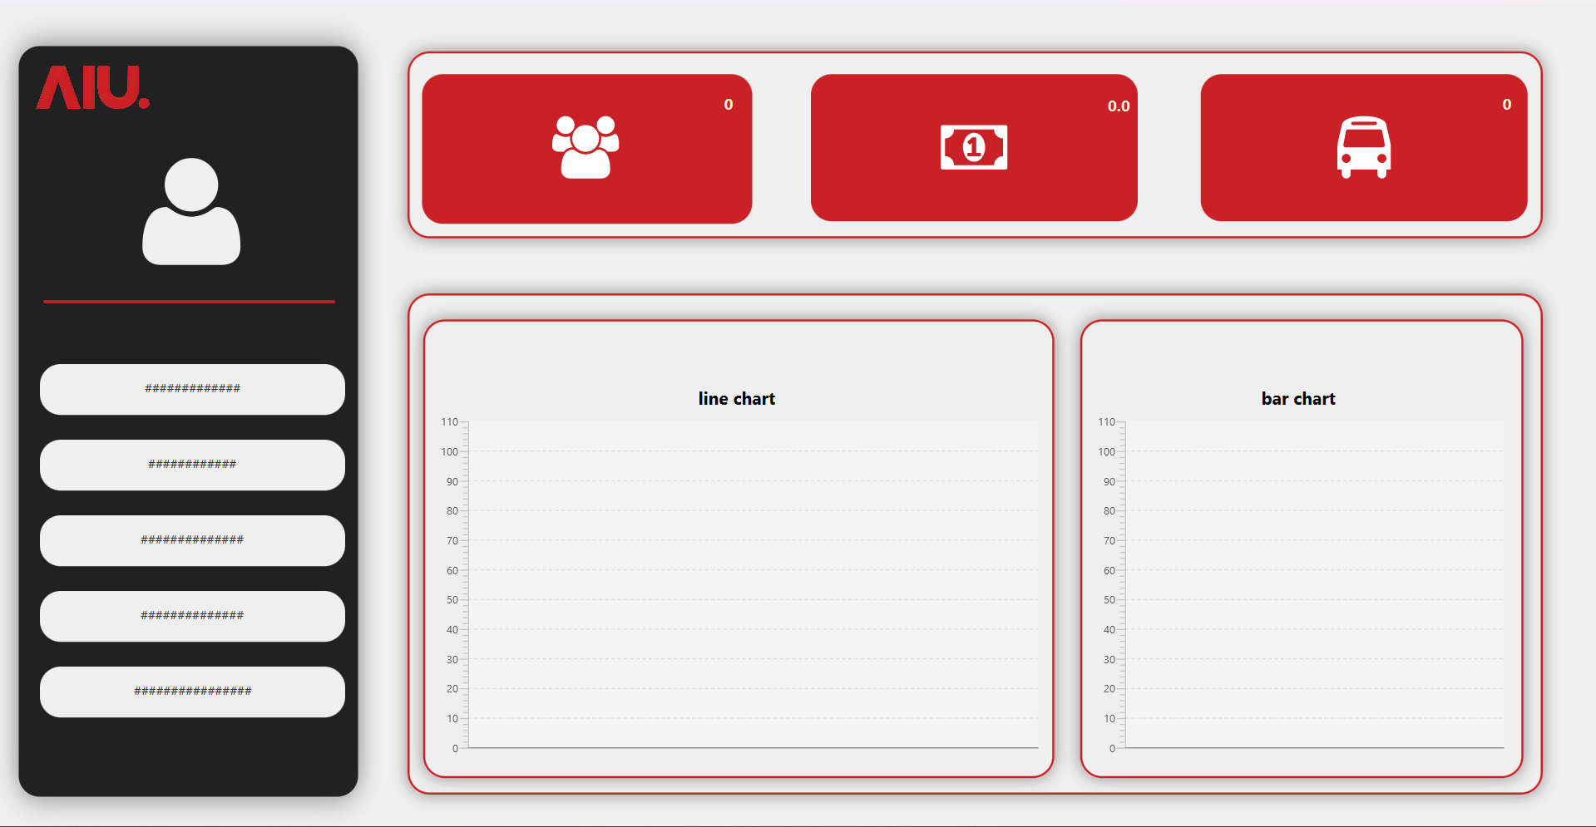

This Interface allows admins to see the number of students who rode the buses the amount of revenue number of buses in operation and a monthly chart showing the number of students using the service

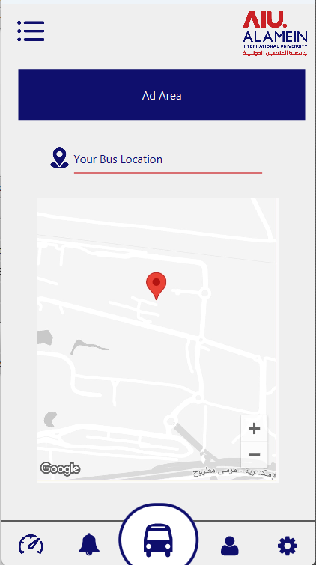
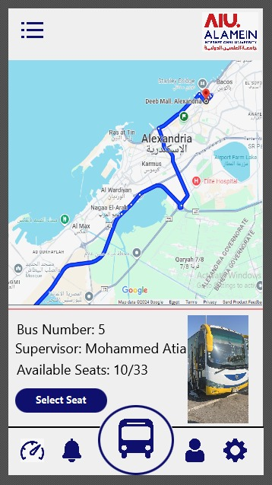
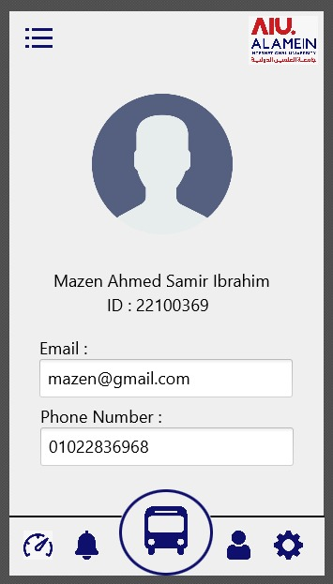

this is a basic GUI for each user profile that displays user's name and uni ID, also their email, photo and phone number
this for student to track there bus location and navigate through notifications, booking, profile, setting and dashboard
this is a basic GUI for each bus that displays bus ID, supervisor name, number of available seats and bus routes

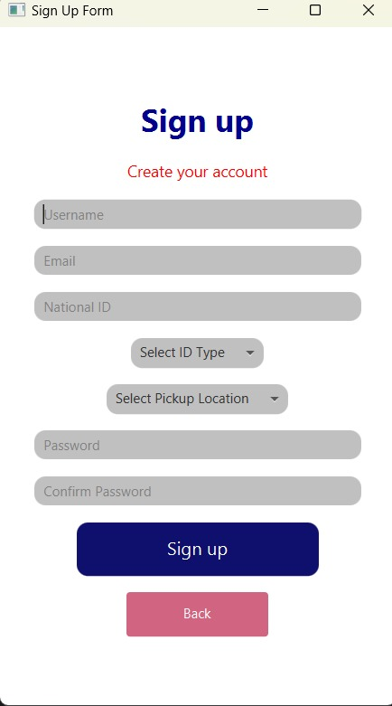
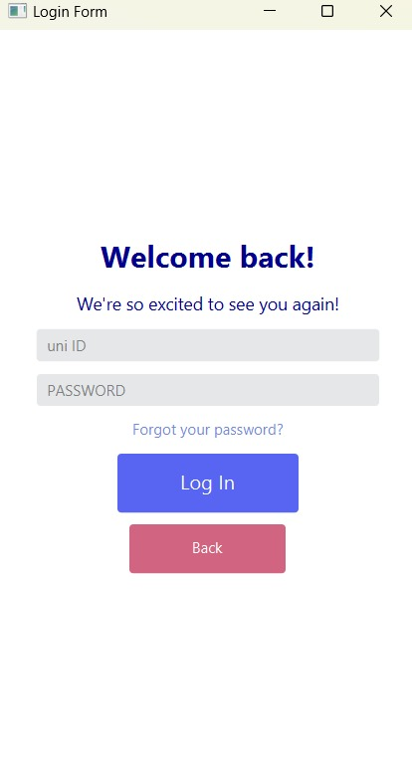

Login Form: The login form is designed for returning users, allowing them to log into their accounts with their unique ID and password. It also offers a "Forgot your password?" link to help users recover their credentials. The interface is clean and minimal, with focus on ease of access.
Sign Up Form: This form allows new users to create an account by providing essential information such as username, email, national ID, password, and preferred pickup location. It offers user-friendly elements like drop-downs and password confirmation to ensure accuracy and a smooth sign-up process.

GITHUB

